Alright, lets go do some internal commits and edits and i'll say when to
push it to main.

In the lobby, make it so the OSRS module is visible, and add a randomizer button to your character customizer.

Remove MOBA range, and Shooter range, add the options to character select, or buy phase in their respective game mode.

The Twins is fine, adjust the fire guys speed to be faster than wind, so he goes first, then give them dual elements. And 2 weapons

Wind gets wind and thunder, and bow and daggers
Thunder gets thunder and dark, and bow and staff
Fire gets dark, and lance and staff

For Dust map, adjust the map, have the spawn be somewhere not in enemy vision, like a tucked in corner, so enemy can’t see you, randomize the spawn between two sides so the opponent can’t just lazily know you’re coming from one end, add some obstacles in the hallway to prevent long sight lines. Or add more lanes to your discretion.

For all FPS games,
Desert eagle recoil feels amazing, meaningful and shocking, add that recoil profile to assault rifle and sniper rifles and shotgun

Sniper scope and automatic rifle should have a low definition preview for “what you would see if you could see through the scope. Tighten the reticule when stationary, 0 still feels too big on the adjuster
Inaccuracy when running can be increased, 3 feels a bit too tight with 0 reticle gap

Pistols when aimed down sights should be further from the camera, make it like a foot away. From the screen camera.

Slight increase to weapon sway, 2.3 feels pretty good, there should be some sideways sway, especially when scoped in

Recoil kick maxed out feels fine for basic pistol and not impactful on the personal carbine, up it.

I really like the floaty movement when you max out movement speed, but only want it implemented on campus paintball.

I like the max length bullet trail, but have it fade basically to 0 at barrel, and increase to full opacity about 3feet away from barrel. Work on the muzzle flash, gauntlet review with, and scale to each weapon.Muzzle Flash | Effects and Simulations models | Blendkit,

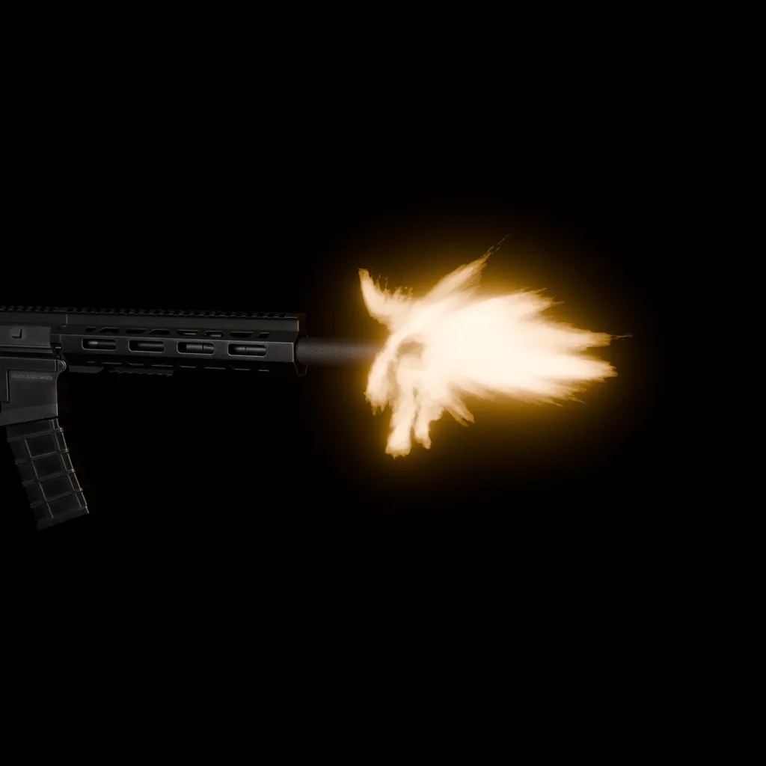

For all raids

Add some usage or something to click for the bottom taskbar, give them healing potions or damage increase potiosn or something, the first tiem someone plays this they should be overwhelmed at the amount of options and things they have to do at the same time as they learn the fight and their character.

For Raid Night: Giants have the circular floor spin more often and with less warning.

For the “prediction chevrons” trim the edge of the “W” that points backwards to make it more clear.

After 75% cast both “group up” and “spread out” in quick succession. Forcing rapid movement.

Make the cinderburn more noticeable like set hte character on fire.

For The tank fight, make the burning remainder AOE be much more clearer, red circle with clear outline, i can barely see it. Love the fight otherwise. I would definitely trim back on the announcer telgraphing the moves, the visuals say a LOT and i think the announcer bar gets too busy. I would be fine with outright removing it.

Change the Light Tank’s actions, have them sit still, and sitting back to back so they fire consecutively in a large ‘denying” zone in front of them. This way they are optional to kill but still useful to kill to give you some breathing room.

Lower the enrage to 1.5x speed, have it occur at 15%

For OSRS Module Have the units on the flanks attack with “prayable auto attacks” and the main target do the specials

Have the main target cast the “remove farthest row” much more often, probably a row per 5-10% hp lost or so.

Tighten the big slam’s 3rd hit to be just the center column is safe.

Accelerate the big slam’s time between hits after 50%.

Add a damage potion to the inventory.

Add a lightning dagger to inventory, it has a 1tick attack speed but deals 1 damage

Add the “skull phase” at every 25%, the main boss will spawn 5-10 skulls on the board, player should swap to lightning dagger and kill all skulls or else they will deal big damage.

For MOBAs, make left click move only, make right click “attack” the attack command will prioritize beggining to auto attack an enemy over movement. The ideal playsyle would be the user moving and kiting with left click, and attacking with right click. Increase ranges of everything by 25%

Change the angle of the camera by about 15% lower to the ground, so you can see more of everything at an angle

Remove the auto attack ring around the character at 30s.

Add to Moba Range options
“Slow cast” pressing an ability or keybind shows the range and projectile shape, pressing the abilityor keybind again casts it
“Release cast” holding an abilityor keybind shows the range and projectile shape, releasing the abilityor keybind casts it
“Quick Cast” Pressing an ability casts it.

Work on some new Blender animations for the stick figures
“Skipping”
“Godly floating” (twins should have this)
“Cool walk” more nonchalant, braves should walk with one hand holding his gun (make the gun steel gray) basically along his leg, and more leaned back and less rushed

add cast animations to everything, not just visuals, but your character should stop for ~.3s to cast. you have to stay still ,take some millisecond and cast

Hovering over abilities should give some detail and tooltips, just like how Raid night has it

Give Merr mage equipment, vary his colouring a smidge
Merr should get godly floating movement animation

Temu should get some ranger equipment
Temu gets skipping animation

Braves should get some ranger/tank equipment
Braves get cool walk animation
Lower Braves’ e movement to 25% of current distance

Increase flash distance to 525

Slow Brand’s q projectile by 30%
Slow W’s grow by 30%, slow R by 100%,

Double everyone’s health at minimum.

Add “pings’ on the giant fight that your team will respond to, v for go in/be aggressive, c for stay or hold here, be edefensive.

Reduce giant’s damage by like 75%, and instead of the center of the map, put him the quadrant closer to the edge, add some impassable rocks and line of sight

Your character should have 2x as much stats as everyone else. Nobody else gets smite but the players.

Distinguish between smite and flash on the toolbar

When temu is hidden have him go 75% transparent

Let me know if there’s a general direction for these changes or what , ithink iterative changes will work, but may take more time than expected. Otherwise i do like a lot of the gameplay so far.

